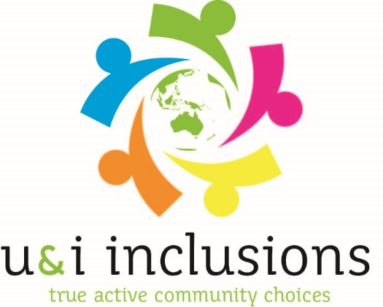
Name: __________________________(Optional)

U&I Inclusions Pty Ltd Feedback Form

- How did you find out about U&I Inclusions Pty Ltd services?
________________________________________________________________________________
________________________________________________________________________________
- From 1 to 10 ( 1 being poor and 10 being excellent) how would you rate the intake process of U&I Inclusions Pty Ltd? Please circle your score.
- What suggestions do you have to improve this process?
________________________________________________________________________________________________________________________________________________________________

- From 1 to 10 ( 1 being poor and 10 being excellent) how would you rate the services offered through U&I Inclusions Pty Ltd? Please circle your score.
- What suggestions do you have to improve this service?
________________________________________________________________________________________________________________________________________________________________

- What services offered through U&I Inclusions Pty Ltd made them the choice of service delivery?
________________________________________________________________________________
________________________________________________________________________________
________________________________________________________________________________

- From 1 to 10 ( 1 being poor and 10 being excellent) how would you rate U&I Inclusions for participant focused, family orientated, choices, independence & community engagement? Please circle your score.
- What suggestions do you have to improve this service?
________________________________________________________________________________
________________________________________________________________________________

- From 1 to 10 ( 1 being poor and 10 being excellent) how likely are you to recommend U&I Inclusions Pty Ltd to other members of the public? Please circle your score.
Thank you for taking the time to complete this feedback form. We take your feedback very seriously so we can improve services for participants of U&I Inclusions Pty Ltd.

