VICTORIA’S CHARTER OF HUMAN RIGHTS & RESPONSIBILITIES

You have the Right to:

Access: the care and support you want and need

Safety: high quality support and care

Respect: to be treated with dignity and without discrimination

Communication: to be informed about your NDIS funding and plans, options with NDIS funding

Participation: to be included in decisions and to make choices about your NDIS funding and programs

Privacy: confidentiality of your personal information

Feedback: a right to comment on your support services and programs, and to have any concerns addressed in a timely manner

You have the Responsibility to:

Respect: U&I Inclusions employees, volunteers and equipment

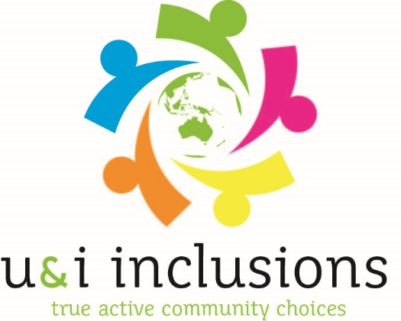
Behave: in a way that is not abusive, offensive or violent

